**Effects of Geometric Parameters on the Ice Accretion and Aerodynamic Performance Degradation of the**

**Multi Element Airfoil**

Department of Aerospace Engineering and Applied Mechanics

**Contents**

Abstract ……………………………………………………………………………………..4

1.Introduction…………………………………………………………………………….5-11

2. Governing equation and Computational model………………………………………….11

3.Sampling based on Low discrepancy Sobol sequence……………………………… 11-13

4.Results and discussion………………………………………………………………….13-23

4.1 Grid independent study and validation of computational work………………………23

4.2. Multi-element geometric parameters and their position envelope……………………23-25

4.3. Calculation of Ice shape attributes……………………………………………………25-28

* 1. Effect of Slat and flap movement on Ice shape attributes

4.4.1. Effect of Slat movement ………………………………………………….29-30

4.4.2. Effect of Flap movement …………………………………………………31

4.5.Effect of Slat and flap movement on aerodynamic performance

4.5.1.Slat movement……………………………………………………………31-34

4.5.2.Flap movement………………………………………………………….34-36

5.Conclusion…………………………………………………………………………….37-38

References………………………………………………………………………………..39-42

**Abstract**

High lift devices are integral to the design, maintenance, safety, and performance of nearly all commercial aircraft. Their design complexity stems from factors such as flow dynamics, actuation systems, geometry, and system support. This complexity is particularly pronounced in three-element high lift systems, where the positioning of the slat and flap greatly influences aerodynamic performance. Also comprehending ice buildup and the resulting decline in aerodynamic performance is crucial within every aircraft certification initiative to guarantee safe flying in icy environments. Apart from the established meteorological icing parameters and flight conditions, various geometric parameters are recognized to be crucial in the ice accretion process on aircraft surfaces. This study examined the sensitivity of six attributes of ice shape and ice mass of the three-element airfoil to four essential geometric parameters utilizing a high-fidelity computational approach. For the sensitivity analysis, sampling points in the designated design space were generated using the Sobol sequence sampling method, the radial basis function, and Sobol’s method. In this study we used 12 different locations of flap and slat and showed the changes in six ice shape attributes, ice mass and also studied the changes in lift and drag coefficients due to ice accretion.

**1.Introduction**

High lift devices are frequently employed in commercial aircraft to achieve the necessary lift during take-off and landing [ 1]. Typically, an airplane's stall speed during these phases depends on factors such as its weight, wing planform area, free stream density, and the maximum lift generated by the wing (Clmax) at a given velocity. A higher Clmax value results in a lower stalling speed, which is advantageous for reducing the required take-off and landing distance. Additionally, a higher Clmax during landing enhances aircraft control during touchdown. Many transport aircraft opt for three-element high lift devices over four or more elements due to the considerable maintenance costs and manufacturing complexities involved. It's noteworthy that well-designed high lift systems have the potential to increase payload capacity and decrease the required landing gear height for a given tail strike attitude angle [1].

In three-element high-lift systems, the Clmax is augmented through three mechanisms: First, by increasing the effective camber of the airfoil via deflection of the flap and slat; second, by enhancing the "virtual angle of attack" perceived by the free stream flow; and third, by expanding the effective "virtual area" of the airfoil with extended slat and flap. Additionally, the secondary effects of the slot (gap) between the slat/flap and the airfoil’s main element facilitate airflow passage through these gaps, thereby re-energizing the flow over the trailing airfoil elements and postponing flow separation. This flow phenomenon enables the three-element airfoil to attain a higher angle of attack before encountering stalling effects. Typically, a hydraulic or pneumatic actuator, powered by the aircraft’s primary or auxiliary power unit, controls the movement of the slat and flap [ 2]. A meticulous trade-off analysis is imperative in the aerodynamic design of the high-lift system, encompassing considerations such as aerodynamic efficiency, maximum lift of the aircraft, and lift generation at the maximum tail scrape angle during take-off and landing [1,2].

The flow dynamics within a three-element airfoil present complexity due to the interactions between flows and the narrow gap between its elements [3]. Notable effects of the slat and flap include the creation of a re-circulation zone in the slat element's cove region, the generation of a confluent layer from the slat's trailing edge interacting with the main element's boundary layer, and the re-circulation occurring in the main element's cove along with the boundary layer/wake interaction between the main element and flap. It's noteworthy that the positioning of the slat and flap significantly influences the flow behaviour over the multi-element airfoil [ 2,3]. The general flow behaviour and interactions over a multi-element airfoil are depicted in Figure 1.

Top of Form

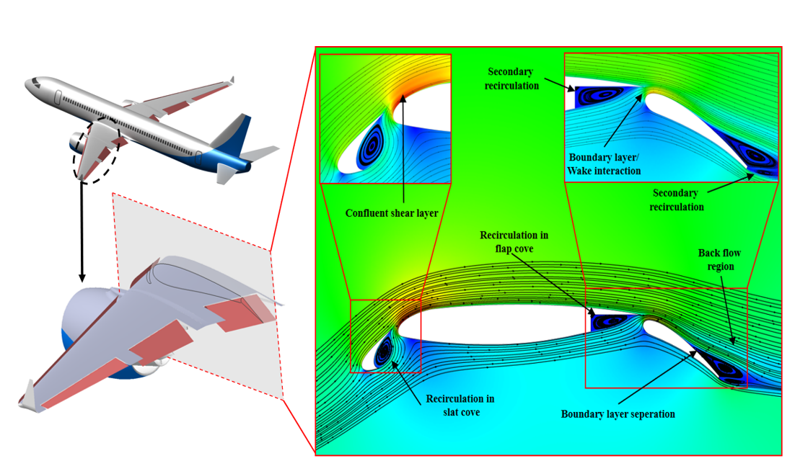

Figure 1. Factors impacting the airflow over a multi-element airfoil (cite)

In a three-element airfoil, each component exerts individual and interactive influences on aerodynamic performance. For example, the slat effect serves to diminish the maximum negative pressure on the leading edge of the trailing (main) element. This occurs because the circulation generated by the forward element induces a flow on the trailing element, thereby mitigating the natural acceleration of the latter. Consequently, the demands for pressure recovery are lessened, delaying flow separation [3]. Conversely, the circulation effect of the trailing element induces flow on the forward element, consequently enhancing lift and diminishing pressure recovery requirements [3]. The high-speed flow over the top surface of the trailing element causes the flow over the forward element to depart at high velocity, thus reducing pressure recovery for the forward element, a phenomenon known as the dumping effect [3]. This effect also supports off-surface pressure recovery mechanisms, which are more efficient than recovery mechanisms in direct contact with the surface [3]. Lastly, a distinct boundary layer forms for each element, resulting in an overall reduction in boundary layer thickness, enabling it to withstand stronger pressure gradients [3,4]. The design of high lift systems has been explored since the early days of aviation, dating back to the 1950s. However, it wasn't until the 1970s that significant advancements were made in both theoretical frameworks and experimental investigations [5–8]. Studying multi-element airfoils poses slightly greater complexity compared to single-element airfoils in various aspects. In experimental setups, the rigging process for multi-element airfoils is cumbersome and introduces more uncertainties into the final results. Placement of pressure ports, data acquisition, and force measurements present greater complexities compared to their single-element counterparts. Conversely, computational simulations of multi-element airfoils have proven to be efficient and increasingly accurate with the advancement of new computational methods. Nevertheless, computational approaches suffer from drawbacks such as over/under prediction of results, inability to capture real-world flow phenomena, and high computation time.

Numerous experiments on multi-element airfoils have been conducted since the inception of high lift devices [5–7,9,10]. Valerazo et al. [5,10] conducted experimental investigations on the flow over multi-element airfoils at various Reynolds and Mach numbers. They further extended their study to optimize multi-element airfoils for maximum lift at high Reynolds numbers [6]. Chin et al. [7] experimentally examined the flow field over multi-element airfoils at high Reynolds numbers and various flap positions, finding that increased Reynolds numbers led to larger wake sizes behind the main element. Spaid et al. [8] conducted flow field measurements of multi-element airfoils at high Reynolds numbers with different slat and flap positions relative to the main element. Lin et al. [11] conducted a parametric investigation of high lift airfoils at high Reynolds numbers, identifying optimal slat and flap locations for maximizing the lift-to-drag ratio. Allan et al. [12] investigated the pressure distribution around Joukowsky airfoils with slotted flaps under various flow conditions and angles of attack, demonstrating the effectiveness of slotted flaps in enhancing lift characteristics during take-off. Pomeroy et al. [13] experimentally investigated multi-element airfoils for large wind turbines, emphasizing the necessity of considering multi-element airfoil design as a unified entity rather than designing slats, main elements, and flaps separately. Another recent experimental study on multi-element airfoils by Ling Li et al. [ 14] focused on the aeroacoustic behaviour of airfoils with Kevlar cloth and perforated plates. Various computational methods have been explored for analysing both two-dimensional airfoils and three-dimensional high lift systems. Brune et al. [15,16] presented illustrative cases highlighting the trade-off between inviscid and viscous effects governing the flow behaviour of multi-element airfoils. Their study on multi-element optimization underscored the significance of both viscous and inviscid flow phenomena and demonstrated the effectiveness of computational methods in capturing these physics. Anderson et al. [17] developed a computational approach based on Navier-Stokes equations to simulate multi-element airfoils, validating their results against experimental data. Rogers et al. [18,19] compared computational simulations of multi-element airfoils using different turbulence models and found that the k-ω SST (two-equation) and Spalart Allmaras (one-equation) turbulence models yielded similar results at lower angles of attack. Rumsey et al. [20] predicted flow phenomena around high lift devices using various turbulent closure models and investigated the effect of transition location on turbulence modelling, finding that both the Spalart Allmaras (S-A) model and Explicit Algebraic Stress Turbulence Model (EASM) accurately predicted transition location.

Moreover, numerous computational and optimization investigations have been conducted on multi-element airfoils to explore various flow physics [21,22,31,23–30]. The aerodynamics of multi-element airfoils are inherently dependent on geometric design and the spacing between elements, with the position of the slat and flap relative to the main element exerting significant influence on flow interactions. Extensive studies on the effects of slat and flap configurations on multi-element aerodynamics have been reported in previous literature [5–8,10,11]. However, a comprehensive understanding of the sensitivity of geometric parameters to the aerodynamic performance of multi-element airfoils is lacking. Hence, investigating the sensitivity of slat and flap positions on multi-element airfoil aerodynamics is crucial.

The accumulation of ice on aircraft when flying through icing clouds poses a significant safety risk to aircraft operations [31,32]. In addition to other safety-related certifications, icing certification is necessary to ensure safe flight in icing conditions before aircraft operation. Various engineering methodologies are accessible for utilization in aircraft icing design and certification processes. These methods include analysis [33,34] and computational fluid dynamics (CFD) [35, 36], tunnel testing (dry and icing wind tunnels) [37-41], flight testing (artificial ice shapes, icing tanker, and natural icing) [42-44], and similarity arguments for derivatives of an aircraft. Essential modeling parameter in ice accretion involves how the airflow field and ice accumulation are treated over time. As depicted in Figure 2, the conventional single-shot approach, which is less time-consuming, computes the ice shape solely based on the initial airflow field and droplet solution. In contrast, the accurate but more time-consuming multi-shot approach updates the airflow field and droplet solutions after a certain number of ice accretion time steps, along with automatic grid regenerations.

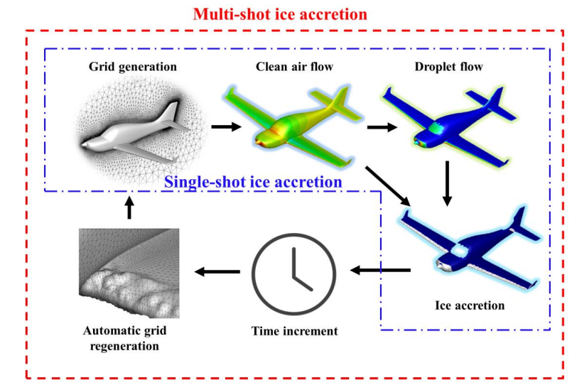

Figure 2. Illustration of single shot and multi shot approach Top of Form

In 2005, Miller et al. [45] conducted experimental investigations into the impact of meteorological parameters (liquid water content, median volumetric diameter, and temperature) on ice formation. These experiments were conducted on a NACA0012 airfoil in the Icing Research Tunnel (IRT) at NASA Glenn Research Center. The findings revealed that the ice horn angle and mass were notably influenced by variations in the meteorological parameters. Additionally, utilizing the experimental data from Miller et al., Campbell [46] explored the sensitivity of airfoil aerodynamic performance degradation to meteorological parameters. Campbell assessed the effects of meteorological parameters on ice formation geometry, which was characterized by normalized horn height, ice horn angle, normalized horn position, normalized icing limit, and ice mass, as depicted in Figure 3.

Top of Form

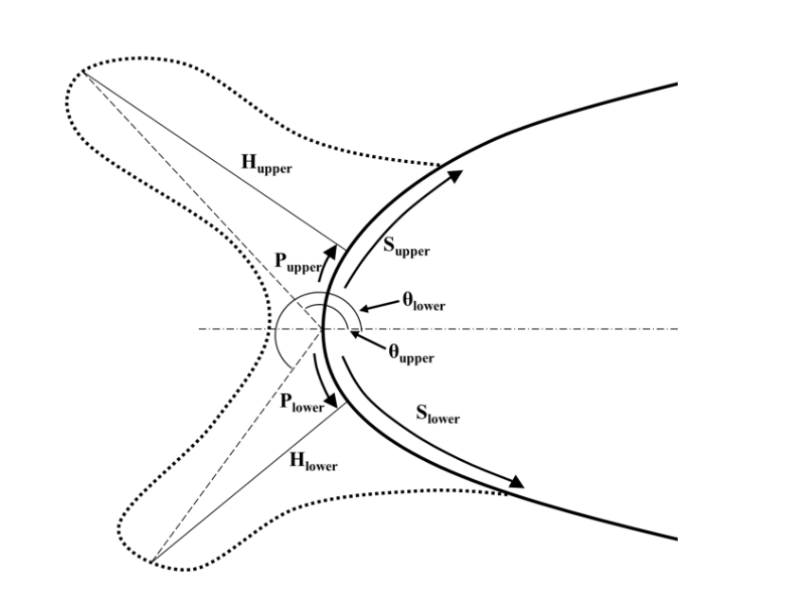

Figure 3. Ice geometry attributes involved in the evaluation of the critical effects of the geometry parameters

Many investigations on the aerodynamic degradation of iced airfoils have also been reported in the literature . For instance, Marongiu et al. [47] investigated the flow field over an NLF-0414 airfoil with a prescribed ice shape using three different flow solvers with two turbulence models. Recently, Chen et al. [48] investigated the aerodynamic characteristics of an iced rotor in forward flight. Recently Prince et al. studied how sensitively critical physical and modelling parameters affect the modelling of ice accretion and aerodynamic performance degradation [49].Abubacker and Prince Raj systematically investigated the effect of slat and flap position on the aerodynamic performance of the three-element airfoil [50].

The present work systematically studied the effect of slat and flat position on the icing attributes and aerodynamic performance of the three-element airfoil. Due to this a computational model is validated with the experimental results. The exploration of the aerodynamic characteristics of the multi-element airfoil begins with the acquisition of sampling points within the designated area of study. A sampling technique based on Sobol sequences is employed for this purpose. A sampling technique based on Sobol sequences is employed for this purpose. Finally, a comparative study of aerodynamic characteristics before and after icing is done and the effect of slat and flap movement on the ice shape is shown.

Top of Form

**2. Governing equations and Computational Model**

The compressible Navier-Stokes equations are the governing equations for the airflow field , which can be expressed as

 (1)

Where

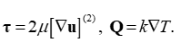 (2)

In this context, ρ, u, p, and E denote the density, velocity vector, pressure, and total energy of the air, respectively. The variables τ and Q represent the viscous shear stress tensor and heat flux vector, respectively. Within equation (2), the notation [A] signifies the trace-less symmetric component of tensor A in the viscous shear stress tensor. The parameters μ and k stand for viscosity and thermal conductivity, respectively, both of which are temperature-dependent for air. The ideal gas equation of state defines the flow field. Turbulence in the flow field is addressed using the one-equation Spalart Allmaras model, known for its accuracy and computational efficiency, as evidenced by prior studies. The Navier-Stokes equation, along with the turbulent model, is solved using the widely recognized commercial software Fluent.

**3. Sampling based on Low discrepancy Sobol sequence**

Sampling is crucial for exploring the design space and determining the distribution of design points within that space. Various methods exist for sampling points, including pseudo-random, stratified, Latin hypercube sampling (LHS), Hammersley, and Sobol sequence . As mentioned earlier, the Sobol sequence is primarily employed in this study due to its effective low discrepancy sampling capability. The Sobol sequence falls within the category of quasi-random sampling methods. The process starts with selecting a dimensionality for the sequence and initializing parameters such as the number of points (sample size) and the number of dimensions. Sobol sequences rely on carefully chosen primitive polynomials and initial direction numbers for each dimension. These direction numbers determine the increments along each dimension.

Figure 4 illustrates the variables x1, x2, and x3 plotted against each other to visualize the sampling design points in three distinct manners. It's evident that the Sobol sequence method evenly distributes the sampling points within each design space. This approach is recognized for its diminished discrepancy when exploring parameter spaces with higher dimensions, distinguishing it from alternative sampling techniques. Moreover, sampling utilizing this method tends to achieve true mean convergence more rapidly than other approaches. The current study focuses on sampling points involving four parameters (variables).



1. (b) (c)

Figure 4. Sobol sequence-based sampling for three parameters plotted against each other (a) x1 vs x2 ,

(b) x2 vs x3 , (c) x1 vs x3

The locations of flap leading edge and slat trailing edge points as generated by the Sobol sequence are

**Table 1.** Coordinates of Slat and flap points

|  |  |  |  |  |
| --- | --- | --- | --- | --- |
| Case number | Slat  X location(mm) | Slat  Y location(mm) | Flap  X location(mm) | Flap  Y location(mm) |
| 1 | 1.69295 | 2.18279 | 0.87628 | -3.20144 |
| 2 | -1.9008 | 0.91716 | 3.55378 | 1.52356 |
| 3 | 3.8492 | -9.20784 | 0.49378 | -2.67644 |
| 4 | 2.4117 | -6.67659 | 4.31878 | -1.62644 |
| 5 | -5.13517 | -11.10627 | 0.68503 | -1.88894 |
| 6 | 3.48983 | -6.04377 | 2.21503 | -3.98894 |
| 7 | -0.82267 | -3.51252 | 4.51003 | -2.93894 |
| 8 | 4.92733 | 6.61248 | 1.45003 | 1.26106 |
| 9 | 1.33358 | -4.77815 | 1.06753 | 0.73606 |
| 10 | 2.77108 | 2.8156 | 1.83253 | -2.41394 |
| 11 | 5.64608 | -12.3719 | 3.36253 | -0.31394 |
| 12 | -0.03654 | -12.41145 | 1.1512 | -2.20066 |
| 13 | -2.91154 | -7.34895 | 2.6812 | -4.30066 |

**4. Results and discussions**

**4.1 Grid independent study and validation of computational work**

The computational model's validation involves a three-element airfoil, specifically the McDonnell Douglas MDA 30P30N, previously investigated experimentally at the NASA-Langley Low Turbulence Pressure tunnel . Customarily, the relative positioning of different elements within a high-lift system is determined using rigging parameters. In this case, the slat and flap are set at a fixed deflection angle of 30º, known to optimize the lift-to-drag ratio. Figure 5 illustrates the airfoil geometry alongside the rigging parameters and their respective definitions.

Top of Form

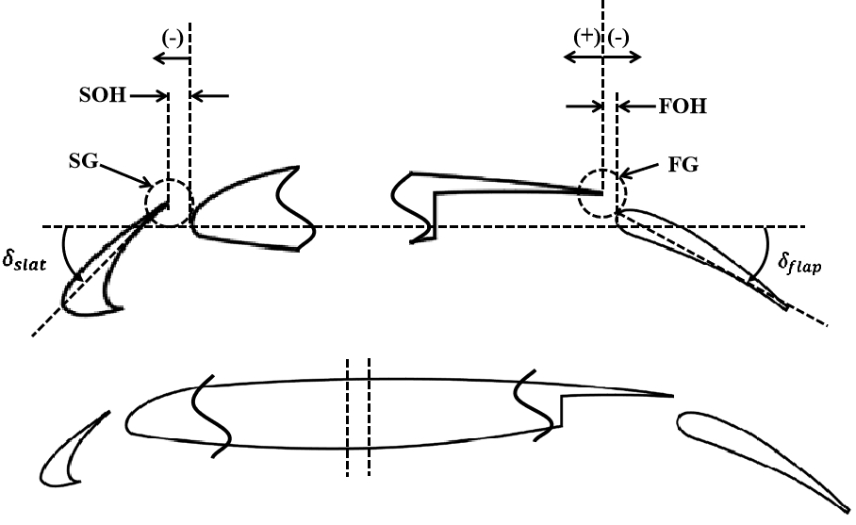

**Main element (fixed)**

Figure 5. MDA 30P 30N airfoil, main element and slat flap rigging parameters

The rigging parameters for the slat and flap refer to the specific settings or configurations used to adjust their positions and angles relative to the main airfoil structure. These parameters play a crucial role in determining the aerodynamic performance of the aircraft during take-off, landing, and other flight phases. The slat gap (SG) represents the radius of a circle drawn from the trailing edge of the slat, touching the main element. This distance influences the airflow behaviour and the formation of vortices around the airfoil. Slat overhang (SOH) measures the horizontal distance between the trailing edge of the slat and the leading edge of the main element. Likewise, the flap gap (FG) denotes the radius of a circle drawn from the trailing edge of the main element, touching the flap. Conversely, flap overhang (FOH) indicates the horizontal distance between the trailing edge of the main element and the leading edge of the flap.

"Stowed chord" refers to the length of a wing or airfoil from its leading edge to its trailing edge when the control surfaces, such as flaps or slats, are in their fully retracted or stowed position. This measurement is crucial in aircraft design and aerodynamics, as it affects the overall wing geometry and performance characteristics during different phases of flight.

Top of Form

|  |
| --- |
| The Stowed chord C=0.559 m |

**Table 2.** The 30P 30N multi-element airfoil geometrical parameters

|  |  |  |
| --- | --- | --- |
| Slat Chord | Cs | 0.15c |
| Main element chord | Cme | 0.83c |
| Flap chord | Cf | 0.3c |
| Slat deflection angle |  | 30º |
| Flap deflection angle |  | 30 º |
| Slat gap | SG | 2.95% |
| Flap gap | FG | 1.25% |
| Slat overhang | SOH | 2.5% |
| Flap overhang | FOH | 0.5% |

The geometric parameters of the three-element airfoil, along with the reference slat and flap rigging parameters, are detailed in Table 2. A domain size of 20C is employed, with pressure far-field boundary conditions and a no-slip wall boundary condition applied to all airfoil elements. Throughout this study, simulations are conducted with a free stream Mach number of 0.2 and a Reynolds number of 9 million.

A grid-independent study is undertaken to ensure an optimal mesh that balances accuracy with computational efficiency. Three different meshes are utilized for this study, and the pressure coefficients obtained for each mesh and two of them along with the experimental results are depicted in Figure 6. The results reveal negligible variation in values between mesh-1 and mesh-2 when compared to experimental data.. Figure 7 illustrates the mesh configuration employed in the present study (mesh-2).

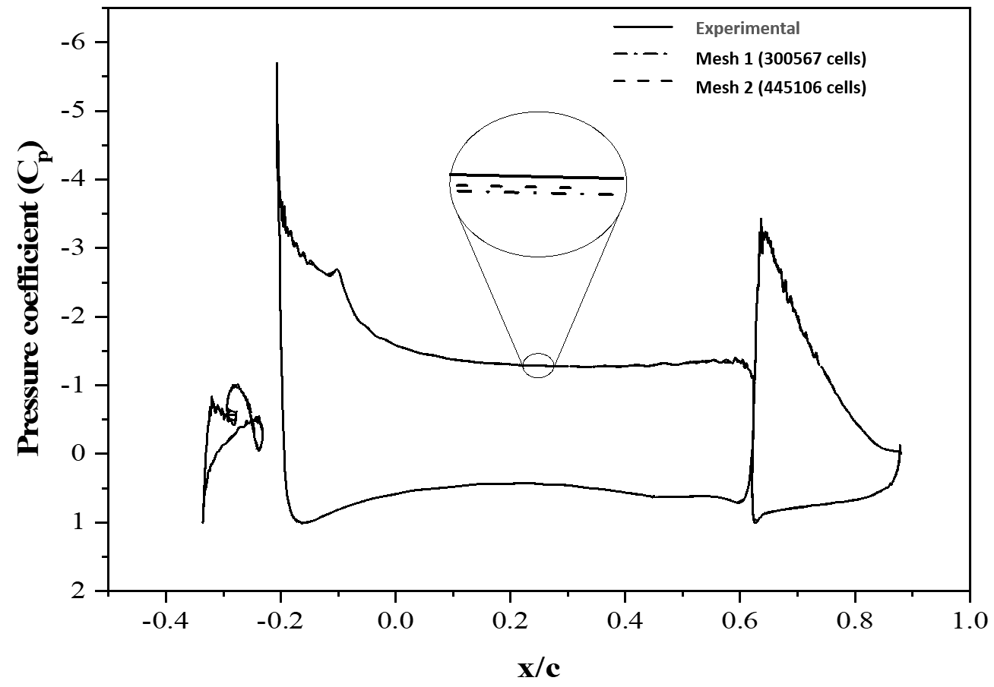

Top of Form

**Figure 6.** Comparison of pressure coefficient around 30P30N multi-element airfoil for different meshes and experimental result at a Mach number of 0.2 and Reynolds number of 9 million



**Figure 7**. Grid distribution of the multi-element airfoil with boundary conditions.

**Figure 8.** . Comparison of lift coefficient between experimental and computational values for a Mach number of 0.2 and Reynolds number of 9 million for MDA 30P/30N airfoil.

Figure 8 illustrates the validation of the lift coefficient for the multi-element airfoil operating at Mach 0.2 and Reynolds number of 9 million. Remarkable consistency is observed when comparing the lift coefficient of the clean airfoil with experimental data. Additionally, Figure 9 presents the pressure coefficients around the multi-element airfoil at 8º angle of attack, demonstrating a close correspondence between computational and experimental results.

16Compare_Slat16Compare_Main

16Compare_Flap.

|  |  |  |  |  |  |  |  |  |  |  |  |  |  |  |  |  |  |  |  |  |  |  |  |  |  |  |  |  |  |  |
| --- | --- | --- | --- | --- | --- | --- | --- | --- | --- | --- | --- | --- | --- | --- | --- | --- | --- | --- | --- | --- | --- | --- | --- | --- | --- | --- | --- | --- | --- | --- |
| **Figure 9**. Comparison of pressure coefficient between experimental and computational values for Mach number of 0.2 and Reynolds number of 9 million α = 8º  Figure 10 displays the pressure contour (left) and velocity contour (right) for a Mach number of 0.2, Reynolds number of 9 million, and an angle of attack of 8°. The computational model consistently reproduces the lift coefficient (Cl), pressure coefficient (Cp), and velocity profiles under these flow conditions. Consequently, it is inferred that the present computational model is capable of accurately predicting the drag for the specified flow parameters. Notably, it should be emphasized that no experimental data regarding drag on the multi-element airfoil are accessible for the specific configuration investigated in this study.  Pressue contour for validation_2 Velocity contour for validation_2  **Figure 10. Figure 10**. Pressure contour at α = 8° (left) and velocity contour at α = 8° (right) for the multi-element airfoil at Mach number of 0.2 and Reynold number of 9 million.  Also the droplet validation is done for slat, main and flap separately by comparing the collection efficiency curve with the experimental values. We studied the validation for three meshes and again found that previous selected mesh gave the best matched results.  **Figure 11**. Collection efficiency around the airfoil elements at α = 80 , M = 0.23, LWC = 1.0 g/m3 , MVD = 20 μm  Ice validation is done on the airfoil with the meteorological and flight conditions as freestream velocity as 102.8 m/s, temperature 263.71k , angle of attack 40 , LWC as 0.55 g/m3, MVD 20 μm,icing time 420 seconds and chord length 0,5334 m. Ice shape also comes to be almost comparable with experimental results.    **Figure 12.** Comparison of ice accretion results with NASA IRT experimental data on an NACA0012 airfoil at the meteorological and flight conditions  **4.2. Multi-element geometric parameters and their position envelope**  To gain a deeper understanding of the airflow around the airfoil, it's essential to thoroughly examine the positions of the slat and flap, exploring a broad range of movements and a wider operational envelope. To facilitate this analysis, the minimum and maximum positions of the slat and flap gaps, as well as overhangs, were determined based on previous research [a 1, 7, 8, 11, 32]. Table 3 presents the minimum and maximum values (expressed as a percentage of the stowed chord, C) for the slat gap, slat overhang, flap gap, and flap overhang, considered for the current investigation.Chord is 0.559 m.  **Table 3.** Slat and Flap rigging parameters for present study   |  |  |  |  |  | | --- | --- | --- | --- | --- | |  | SG[%C] | SOH[%C] | FG[%C] | FOH[%C] | | Minimum | -3.7-3.7 | -3.5 | -0.6 | 0.8 | | Maximum | -1.5-1.5 | -1.5 | 0.5 | 2.2 |   Prior studies examined the influence of slat and flap configurations on a three-element airfoil, maintaining fixed values for slat gap (SG), slat overhang (SOH), flap gap (FG), and flap overhang (FOH) [a 5, 6, 10]. The current research, however, concentrates on exploring a broad range of variations and combinations across all geometric parameters of the multi-element airfoil to capture the full spectrum of flow field effects. To accomplish this, a positional envelope or location map detailing SG, SOH, FG, and FOH is generated, as depicted in Figure 13.    **Figure 13.** Position map or location envelope for slat gap(SG) ,slat overhang(SOH) ,flap gap (FG)Position map or location envelope of slat gap (SG), slat overhang (SOH), flap gap (FG), and flap overhang (FOH).**Figure 10**. Position map or location envelope of slat gap (SG), slat overhang (SOH), flap gap (FG), and flap overhang (FOH). **Figure 10**. Position map or location envelope of slat gap (SG), slat overhang (SOH), flap gap (FG), and flap overhang (FOH).**Figure 10**. Position map or location envelope of slat gap (SG), slat overhang (SOH), flap gap (FG), and flap overhang (FOH).**Figure 10**. Position map or location envelope of slat gap (SG), slat overhang (SOH), flap gap (FG), and flap overhang (FOH).Top of Form  And flap overhang(FOH)  Developing the envelope poses challenges due to two key constraints. Firstly, ensuring the geometric tracing of the slat and flap's reference points lies within the specified minimum and maximum ranges for their respective parameters (as outlined in Table 3). The reference point serves as the basis for translating the slat and flap in the x and y directions, respectively (see Figure 13). Secondly, meeting the fundamental geometrical constraints of the three-element configuration adds complexity. For instance, the slat gap circle, centered at the slat's trailing edge, must be tangent to the main element. Similarly, the flap gap circle, centered at the main element's trailing edge, must be tangent to the flap.  A bounding box is drawn to enclose all extreme points, ensuring the selected points fall within the maximum and minimum design constraints (illustrated in Figure 13). This bounding box is crucial for converting dependent parameters, such as gap and flap positions, into independent x and y coordinates. These coordinates are necessary for defining sampling points as input parameters. Subsequently, these sampling points are used to construct the geometry of the multi-element airfoil, and the mesh is generated for simulations.  The study focuses on the translation of the slat and flap in the x and y directions relative to the origin. This intricate conversion process is carried out manually using modeling software to adhere to the geometric constraints. Table 4 presents the corresponding minimum and maximum limits for the slat and flap locations relative to the origin.  **Table 3.** Converted x and y limits from position map   |  |  |  |  |  | | --- | --- | --- | --- | --- | |  | Slat X trans(mm) | Slat Y trans(mm) | Flap X trans(mm) | Flap Y trans(mm) | | Minimum | -135.3-135.3-135.3-3.7 | -9.6 | 350.5 | 5.8 | | Maximum | -123.8 | 10.6 | 356.6 | 14.2 | |
| The Sobol sequence method generates the sample points (x and y coordinates within limits mentioned above), which are later used to simulate the multi-element airfoil at different slat and flap positions (gap and overhang). The simulation results are then used to plot graphs and higher-order interaction effects of geometric parameter effects on the aerodynamic quantities.  **4.3 Calculation of Ice shape attributes**  We used ‘Catia’ commercial software for getting the ice shape attributes and later we compared the effects of different geometric parameters on the ice shape. In this study , horn angle is not considered , we deal with total six ice shape attributes that are shown in the figure 14.    (a)    **(b)** |
|  |
|  |
| (c) |

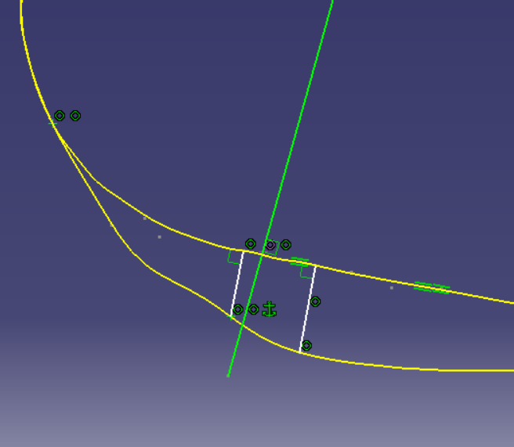

(d)

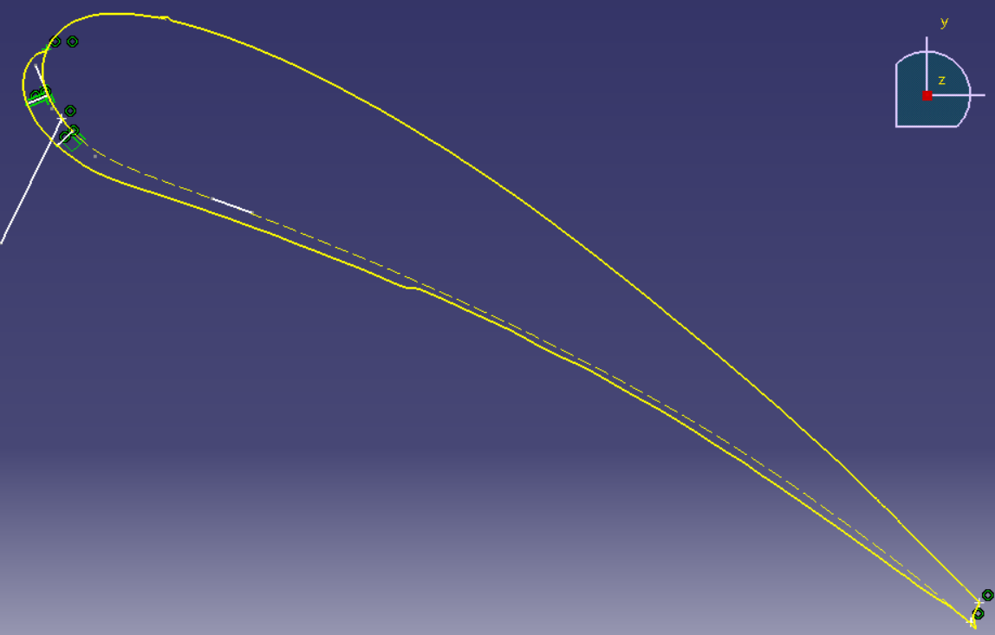

(e)

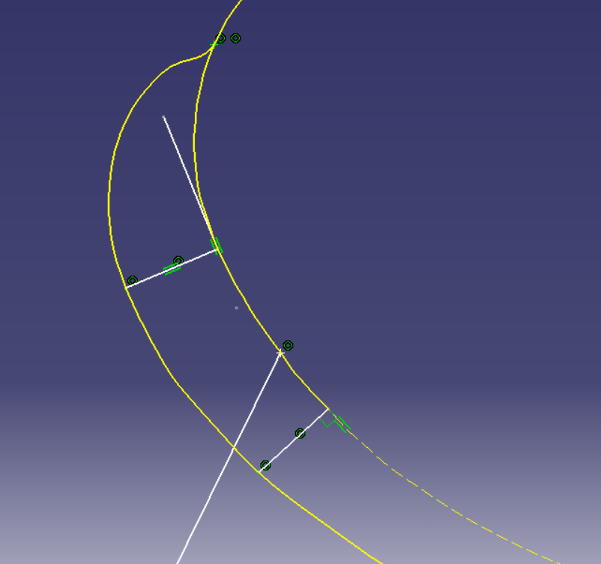

(f)

**Figure 14.** Process of finding Ice shape attributes

**4.4 Effect of Slat and flap movement on Ice shape attributes**

As the coordinates of flap and slat are changed, Ice shape changes rapidly as the flow behaviour changes on the airfoil.

* + 1. **Effect of Slat movement**

Graphs are plotted to show the variation of ice shape attributes with slat movement.

**Figure 15. Variation of Ice shape and mass due to Slat x coordinate change**

Due to ice production as the aerodynamic efficiency decreases minimum ice accumulation is always feasible. Therefore from here we can conclude Slat x coordinate 4.92733 ice mass is minimum.

* + 1. **Effect of Flap movement**

**Figure 16. Variation of Ice mass due to Slat x coordinate change**

For flap also it can be seen ice is becoming minimum at x location 1.45003 of flap. For limited data points this precision of optimum slat or flap position may not be that much correct, but it gives the path way for the broader calculation.

**4.5 Effect of Slat and flap movement on aerodynamic performance**

**4.5.1 Slat movement**

The slat at a zero angle of attack generally produces a negative lift due to its geometrical orientation and position in space. It is worth mentioning that the increase in slat gap and overhang moves the slat away from the main element. It can be seen that the curvature between slat and main element is prone to circulation in figure 17(a). The primary function of the slat is to reduce the suction peak of the main element by generating a large re-circulation zone near the proximity of the main element, as shown in figure 17(b). At lower slat overhang conditions, the stagnation point is shifted downstream, and the flow through the slot is decelerated. This decelerated flow, along with the slat’s high wake region, reduces the generation of negative lift in the slat. As shown in figure 17(c), the increase in the overhang distance reduces the slat’s wake zone, resulting in the increase of suction peak on the main element, resulting in accelerated flow through the slot—consequently, the negative lift increases in the slat element with increasing the slat overhang distance. However, the change in the lift with slat gap at constant overhang is observed to be fairly constant.

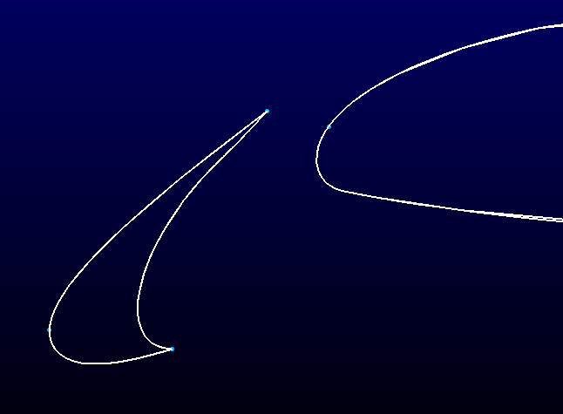 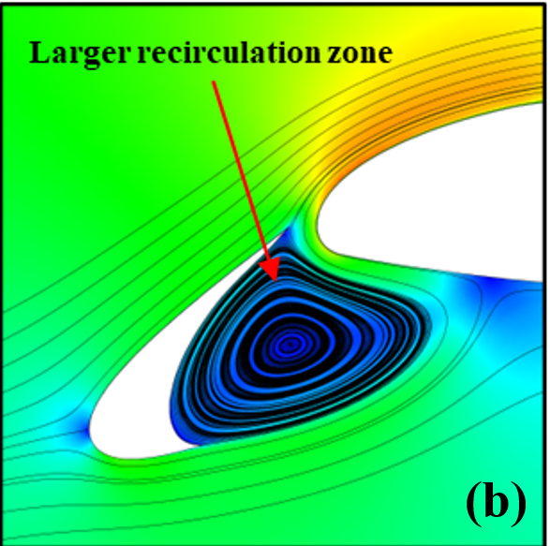

**(a)**

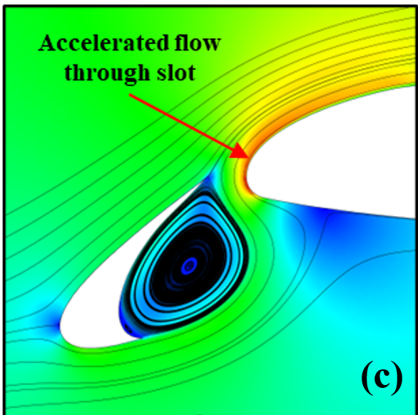

**Figure 17 (a) Curvature between slat and main element, (b) Velocity contour at low slat overhang, (c) velocity contour at high slat overhang**

**Figure 18. Cl change due to icing for different slat x location**

It can be seen in figure 18 how cl change due to icing and another noticeable phenomenon is the negative Cl of slat is becoming positive due to icing. As ice forms on the surface of the wing or airfoil, it creates a rough surface texture. This roughness disrupts the smooth flow of air over the wing, leading to changes in the lift coefficient. Ice accumulation also changes the shape of the airfoil, particularly if the ice forms unevenly or asymmetrically. This change in shape can affect the airflow around the airfoil and subsequently impact the lift coefficient. Presence of ice on airfoil can lead to a reduction in lift. This reduction occurs because the rough surface disrupts the airflow, leading to a decrease in the generation of lift force. Ice accumulation can also cause a shift in the center of pressure of the wing or airfoil. This shift alters the distribution of aerodynamic forces, including lift, and can affect the stability and control of the aircraft. ce accumulation can also lead to a loss of lift efficiency, meaning that the wing produces less lift for a given angle of attack. This can result in decreased overall aircraft performance, including reduced climb rates and increased fuel consumption.

It is observed that the minimum drag generated by the slat is at the minimum gap and overhang distances which may be due to the large wake zone (low re-circulation velocity). The large wake zone generates a high static pressure at the pressure side of the slat, as visualized in figure 19(a). Moving the slat away from the main element results in higher drag that may be due to the lower static pressure zones (high re-circulation velocity) at the slat’s pressure side, which can be observed in figure 19(b). It is worth mentioning that on the suction side of the slat, the pressure remains nearly the same for all the slat positions, which shows that the drag on the slat highly depends on the pressure side.

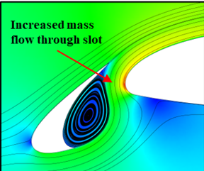 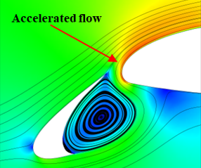

**(b)**

**(a)**

**Figure 19.(a) velocity contour at high slat gap,(b) velocity contour at low slat gap**

**Figure 20. Cd variation with icing for different slat x location**

It can be seen cd value is sometimes lesser than the clean one but for some location of slat Cd value increases due to icing.Lower Cd value is preferable most of the time.

**4.5.2 Flap movement**

It is observed that the lift is reduced at the lower gap and overhang while the lift increases with an increase in flap gap and overhang distance. The flow over the flap is restricted in the vicinity of the main elements trailing edge, thus exhibiting reduced lift at lower gaps and overhang. In general, the flap suction peak increases with the flap gap resulting in an increased lift. The velocity contour shown in figure 20 displays the constricted airflow around the flap in the vicinity of the main element’s trailing edge, causing an increase in the suction peak of the flap.

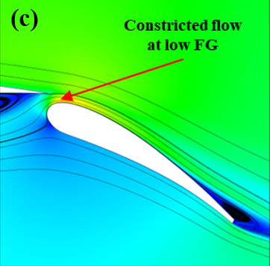 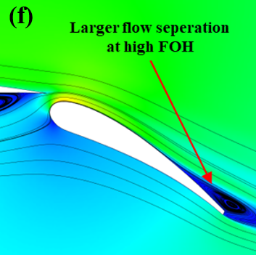

**Figure 20.** **Velocity contour at low flap overhang and velocity contour at high flap overhang**

. Figure 20 shows that the separation bubble’s growth is large at a high overhang distance.

**Figure 21. Change of Cl due to icing in different flap x location**

In figure 21 it can observed that Cl is reducing due to icing in flap and it will contribute to the lift decrement of the whole wing.

**Figure 22. Change of Cd due to icing in different flap x location**

Cd is increasing for some position of flap, high drag coefficients lead to decreased performance in terms of speed, acceleration, and manoeuvrability. Aircraft with larger Cd values may experience reduced climb rates, slower cruise speeds, and longer take-off and landing distances. Similarly, vehicles with high drag coefficients may have slower acceleration, lower top speeds, and decreased handling characteristics. The higher drag associated with a large Cd necessitates more fuel consumption to maintain desired speeds and performance levels. This translates to increased operating costs for airlines, as well as higher fuel expenses for vehicle owners.

1. **Conclusion**

Three-element high lift devices are often used in the airplane industry to increase the take-off and landing performance of large commercial aircraft. Design and optimization of the high lift devices are essential to improve aircraft performance under various flight conditions. Especially, the position of the slat and flap in a three-element airfoil are the critical parameters that affect the performance of a three-element airfoil. However, even though the position of flap and slat are optimized in several previous investigations, questions regarding the criticality of the position of flap and slat have been raised. A systematic workflow is being executed in this work by firstly arriving at the range of the geometric parameters such as slat gap (SG), slat overhang (SOH), flap gap (FG), and flap overhang (FOH) from the previous studies on the multi-element airfoil. In this analysis, airflow simulations are carried out by a finite volume-based computational solver.

High-fidelity PDE-based aerodynamic, icing, and thermal simulations are increasingly being used to produce artificial ice shapes for certification, for determining degradation in aerodynamic performance, and designing the ice protection systems for the safe flight of aircraft in icing conditions. Further, they are used, in direct and indirect ways, to assist in icing tunnel testing and flight-testing campaigns. However, even as these simulation methods are being more frequently applied to real world problems, questions regarding the accuracy and criticality of several geometrical parameters essential to these simulation methods have been raised. In order to tackle this problem, the effect of critical geometrical parameters—on six ice shape attributes and ice mass is being studied. The effects of flap and slat positioning parameters on aerodynamic performance degradation of an iced airfoil were also investigated. In terms of the overall performance of the airfoil, the lift generation mainly depends on the flap position concerning the main element. The maximum lift can be obtained by keeping the overhang of the flap constant at a lower value and increasing the gap so that the camber of the airfoil is increased. On the other hand, the drag of the airfoil varies significantly with the slat gap. The higher the slat gap, the larger the generation of drag.

Further this study can be proceeded with sensitivity analysis, by that it can quantified which geometrical parameter has how much effect on ice attributes and aerodynamic performance. Sensitivity analysis in icing simulation involves assessing the impact of various parameters and inputs on the results obtained from the simulation. This analysis helps identify which factors have the most significant influence on the outcome of the simulation, allowing for a better understanding of the system's behavior and the potential sources of uncertainty.

**References**

[1] van Dam, C. P. “The Aerodynamic Design of Multi-Element High-Lift Systems for Transport Airplanes.” *Progress in Aerospace Sciences*, Vol. 38, No. 2, 2002, pp. 101–144. <https://doi.org/10.1016/S0376-0421(02)00002-7>.

[2] Rudolph, P. K. C. *High-Lift Systems on Commercial Subsonic Airliners*. 1996.

[3] Smith, A. M. O. “High-Lift Aerodynamics.” *Journal of Aircraft*, Vol. 12, No. 6, 1975, pp. 501–530.

[4] Liebeck, R. H. “Design of Subsonic Airfoils for High Lift.” *Journal of aircraft*, Vol. 15, No. 9, 1978, pp. 547–561.

[5] Valarezo, W. High-Lift Testing at High Reynolds Numbers. 1992.

[6] Valarezo, W., Dominik, C., Mcghee, R., Goodman, W., and Paschal, K. Multi-Element Airfoil Optimization for Maximum Lift at High Reynoldsnumbers. 1991.

[7] Chin, V., Peters, D., Spaid, F., and Mcghee, R. Flowfield Measurements about a Multi-Element Airfoil at High Reynolds Numbers. 1993.

[8] Spaid, F., and Lynch, F. High Reynolds Number, Multi-Element Airfoil Flowfield Measurements. No. 37, 1996.

[9] Nakayama, A., Kreplin, H. P., and Morgan, H. L. “Experimental Investigation of Flowfield about a Multielement Airfoil.” *AIAA Journal*, Vol. 28, No. 1, 1990, pp. 14–21. https://doi.org/10.2514/3.10347.

[10] Valarezo, W. O., Dominik, C. J., and Mcghee, R. J. Reynolds and Mach Number Effects on Multielement Airfoils. 1992.

[11] Lin, J. C., and Dominik, C. J. “Parametric Investigation of a High-Lift Airfoil at High Reynolds Numbers.” *Journal of Aircraft*, Vol. 34, No. 4, 1997, pp. 485–491. https://doi.org/10.2514/2.2217.

[12] Allan, W. D. E. *An Experimental Study of Flow about an Airfoil with Slotted Flap and Spoiler Using Joukowsky Profiles*. THE UNIVERSITY OF BRITISH COLUMBIA, 1988.

[13] Pomeroy, B., Williamson, G., and Selig, M. Experimental Study of a Multielement Airfoil for Large Wind Turbines. 2012.

[14] Li, L., Liu, P., Guo, H., Hou, Y., Geng, X., and Wang, J. “Aeroacoustic Measurement Of30P30N High-Lift Configuration in the Test Section with Kevlar Cloth and Perforated Plate.” *Aerospace Science and Technology*, No. August, 2017. https://doi.org/10.1016/j.ast.2017.08.039.

[15] Brune, G. W., and McMasters, J. H. “Applied Computational Aerodynamics.” *Applied Computational Aerodynamics*, Vol. 125, 1990, p. 389.

[16] Foster, D. N., Irwin, H., and Williams, B. R. *The Two-Dimensional Flow Around a Slotted Flap*. 1970.

[17] Anderson, W. K., Bonhaus, D. L., McGhee, R. J., and Walker, B. S. “Navier-Stokes Computations and Experimental Comparisons for Multielement Airfoil Configurations.” *Journal of Aircraft*, Vol. 32, No. 6, 1995, pp. 1246–1253. https://doi.org/10.2514/3.46871.

[18] Rogers, S., Menter, F., Durbin, P., and Mansour, N. A Comparison of Turbulence Models in Computing Multi-Element Airfoil Flows. 1994.

[19] Rogers, S. E. “Progress in High-Lift Aerodynamic Calculations.” *Journal of Aircraft*, Vol. 31, No. 6, 1994, pp. 1244–1251. https://doi.org/10.2514/3.46642.

[20] Rumsey, C. L., Gatski, T. B., Ying, S. X., and Bertelrud, A. “Prediction of High-Lift Flows Using Turbulent Closure Models.” *AIAA Journal*, Vol. 36, No. 5, 1998, pp. 765–774. https://doi.org/10.2514/2.435.

[21] Bonhaus, D. L. *An Upwind Multigrid Method for Solving Viscous Flows on Unstructured Triangular Meshes*. The School of Engineering and Applied Science of The George Washington University, 1993.

[22] Anhalt, C., Breitbach, E., and Sachau, D. Realization of a Shapevariable Fowler Flap for Transport Aircraft. 2000.

[23] Kamliya Jawahar, H., Azarpeyvand, M., and Ilario, C. Experimental Investigation of Flow Around Three-Element High-Lift Airfoil with Morphing Fillers. 2017.

[24] Prince Raj, L., Lee, J. W., and Myong, R. S. “Ice Accretion and Aerodynamic Effects on a Multi-Element Airfoil under SLD Icing Conditions.” *Aerospace Science and Technology*, Vol. 85, 2019, pp. 320–333. https://doi.org/10.1016/j.ast.2018.12.017.

[25] Lee, Y. M., Lee, J. H., Raj, L. P., Jo, J. H., and Myong, R. S. “Large-Eddy Simulations of Complex Aerodynamic Flows over Multi-Element Iced Airfoils.” *Aerospace Science and Technology*, Vol. 109, 2021, p. 106417. https://doi.org/10.1016/j.ast.2020.106417.

[26] Li, D. *Multi-Objective Design Optimization for High-Lift Aircraft Configurations Supported By Surrogate Modeling*. Cranfield University, 2013.

[27] Nakayama, Haruka, Hyoung-Jin Kim, Kisa Matsushima, Kazuhiro Nakahashi, K. T. “Aerodynamic Optimization of Multi-Element Airfoil.” *AIAA Journal*, No. January, 2006, pp. 1–15.

[28] Chen, G., Tang, X., Yang, X., Weng, P., and Ding, J. “Noise Control for High-Lift Devices by Slat Wall Treatment.” *Aerospace Science and Technology*, Vol. 115, 2021, p. 106820. https://doi.org/10.1016/j.ast.2021.106820.

[29] Pehlivanoglu, Y. V., and Yagiz, B. “Aerodynamic Design Prediction Using Surrogate-Based Modeling in Genetic Algorithm Architecture.” *Aerospace Science and Technology*, Vol. 23, No. 1, 2012, pp. 479–491. https://doi.org/10.1016/j.ast.2011.10.006.

[30] Petrosino, F., Mingione, G., Carozza, A., Gilardoni, T., and D’Agostini, G. “Ice Accretion Model on Multi-Element Airfoil.” *Journal of Aircraft*, Vol. 48, No. 6, 2011, pp. 1913–1920. <https://doi.org/10.2514/1.C031346>.

[31] Landsberg B. Safety Advisor: Aircraft Icing. AOPA Air Safety Foundation; 2008.

[32] Jones SM, Reveley MS, Evans JK, Barrientos FA. Subsonic aircraft safety icing study. 2008

[33] AI-Khalil KM. Ice accretion and performance degradation calculations with LEWICE/NS. 31st Aerospace Sciences Meeting and Exhibit: American Institute of Aeronautics and Astronautics; 1993.

[34] Wright WB. Validation Results for LEWICE 3.0. NASA Glenn Research Center; 2005.

[35] Nakakita K, Nadarajah S, Habashi W. Toward real-time aero-icing simulation of complete aircraft via FENSAP-ICE. Journal of Aircraft. 2010;47:96.

[36] Bourgault Y, Boutanios Z, Habashi WG. Three-dimensional Eulerian approach to droplet impingement simulation using FENSAP-ICE, Part 1: Model, algorithm, and validation. Journal of Aircraft. 2000;37:95-103.

[37] Lozowski E, Stallabrass J, Hearty P. The icing of an unheated, nonrotating cylinder. Part II. Icing wind tunnel experiments. Journal of Climate and Applied Meteorology. 1983;22:2063-74.

[38] Fortin G, Perron J. Spinning rotor blade tests in icing wind tunnel. 1st AIAA Atmospheric and Space Environments Conference: American Institute of Aeronautics and Astronautics; 2009.

[39] Mayer C, Ilinca A, Fortin G, Perron J. Wind tunnel study of electro-thermal de-icing of wind turbine blades. International Journal of Offshore and Polar Engineering. 2007;17.

[40] Papadakis M, Yeong H-W, Wong S-C, Vargas M, Potapczuk M. Experimental investigation of ice accretion effects on a swept wing. NASA Glenn Research Center; 2005.

[41] Papadakis M, Hung KE, Vu GT, Yeong HW, Bidwell CS, Breer MD, Bencic, TJ. Experimental investigation of water droplet impingement on airfoils, finite wings, and an S-duct engine inlet. NASA Glenn Research Center; 2002.

[42] Ratvasky TP, Van Zante JF, Sim A. NASA/FAA tailplane icing program: flight test report. NASA Lewis Research Center; 2000.

[43] Shaw R, Richter G. The UH-1H helicopter icing flight test program-An overview. 23rd Aerospace Sciences Meeting: American Institute of Aeronautics and Astronautics; 1985.

[44] Isaac G, Cober S, Strapp J, Korolev A, Tremblay A, Marcotte D. Recent Canadian research on aircraft in-flight icing. Canadian Aeronautics and Space Journal. 2001;47:213-21.

[45] ] Miller D, Potapczuk M, Langhals T. Preliminary investigation of ice shape sensitivity to parameter variations. 43rd AIAA Aerospace Sciences Meeting and Exhibit: American Institute of Aeronautics and Astronautics; 2005.

[46] Campbell SE, Broeren AP, Bragg MB. Sensitivity of aircraft performance to icing parameter variations. Journal of Aircraft. 2007;44:1758-60

[47] Marongiu C, Vitagliano P, Zanazzi G, Narducci R. Aerodynamic analysis of an iced airfoil at medium/high reynolds number. AIAA Journal. 2008;46:2469-78.

[48] Chen X, Zhao Q, Barakos G. Numerical analysis of aerodynamic characteristics of iced rotor in forward flight. AIAA Journal. 2018:1-15.

[49] Raj, L. P., Yee, K., & Myong, R. S. (2020). Sensitivity of ice accretion and aerodynamic performance degradation to critical physical and modeling parameters affecting airfoil icing. *Aerospace Science and Technology*, *98*, 105659.

[50] Raj, L. P., Yee, K., & Myong, R. S. (2020). Sensitivity of ice accretion and aerodynamic performance degradation to critical physical and modeling parameters affecting airfoil icing. *Aerospace Science and Technology*, *98*, 105659.

Top of Form